PROJECT TITLE

TO SUPPLY LEFTOVER FOOD TO POOR

# College Name:SHIRI KUMARAN COLLEGE OF ARTS AND SCIENCE

## ****College code:bru5d****

**TEAM MEMBERS:**

**Team Leader: Devadharshini.S**

**Email:** [devadharshinideva86@gmail.com](mailto:devadharshinideva86@gmail.com)

**Team Member: Megala.A**

**Email:** [selvimegala44@gmail.com](mailto:selvimegala44@gmail.com)

**Team Member: Ranjith.M**

**Email:** [priyamurugan162007@gmail.com](mailto:priyamurugan162007@gmail.com)

**Team Member: Narandraprasanth.R**

**Email:** [narandraprasanth@gmail.com](mailto:narandraprasanth@gmail.com)

INTRODUCTION:

1.1 Project Overview

A project to supply leftover food to the poor serves as a crucial intervention to combat two major global issues: hunger and food waste. This initiative aims to bridge the gap between surplus food in communities and impoverished populations by creating a system that efficiently connects food donors with the needy through a technological platform or established partnerships with NGOs.

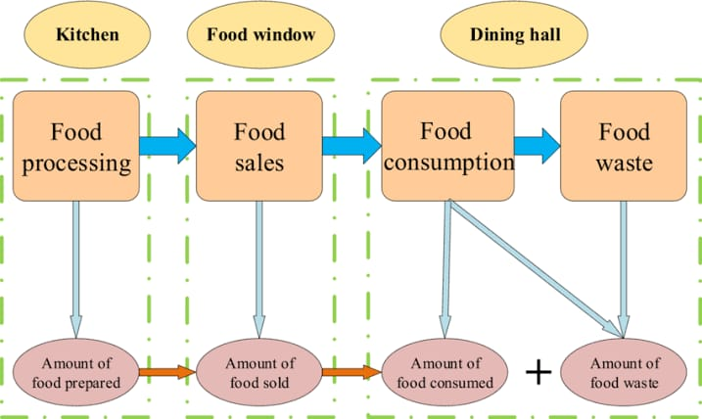

1.2 Purpose

"Supply Leftover Food to the Poor" project aims to combat food waste and alleviate hunger by creating a system to collect surplus food from donors (like restaurants and households) and redistribute it to people in need.

DEVELOPMENT PHASE

Creating Developer Account:

By using this URL- <https://www.salesforce.com/form/developer-signup/?d=pb>

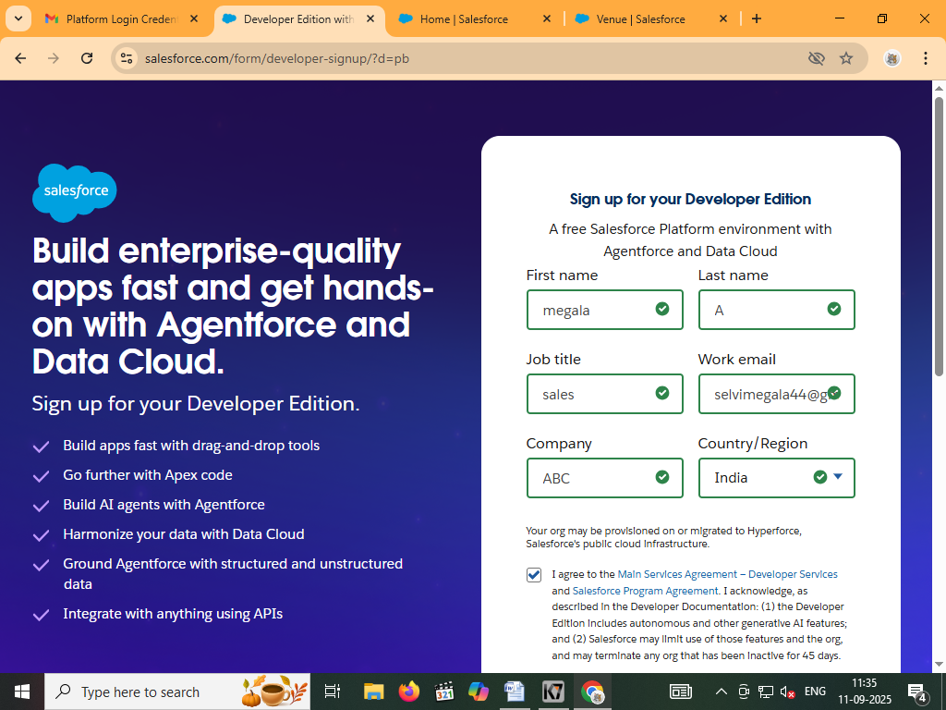

Created objects:Venue,Drop Off point,Task,Volunteer

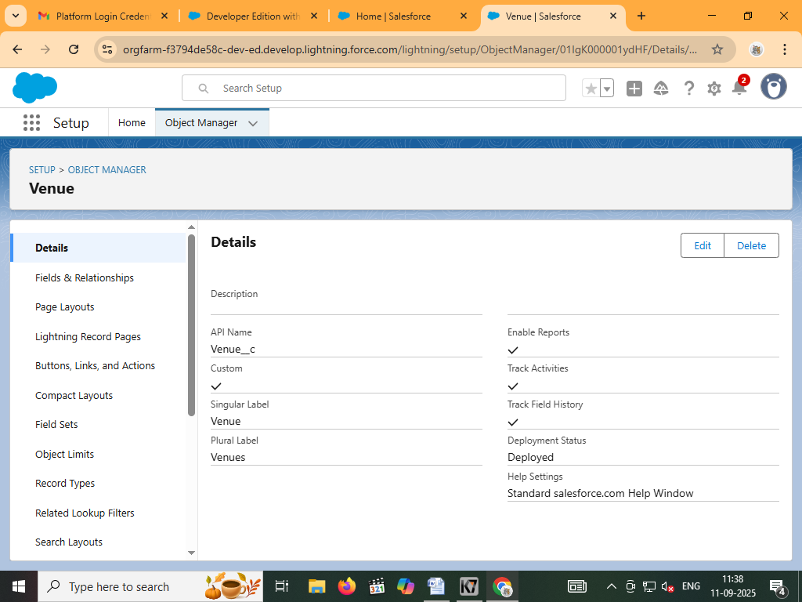

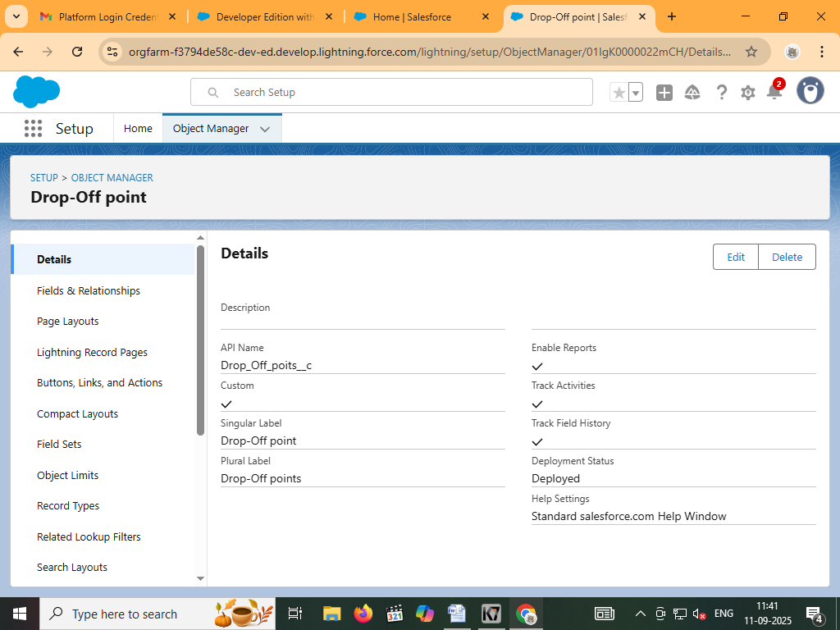

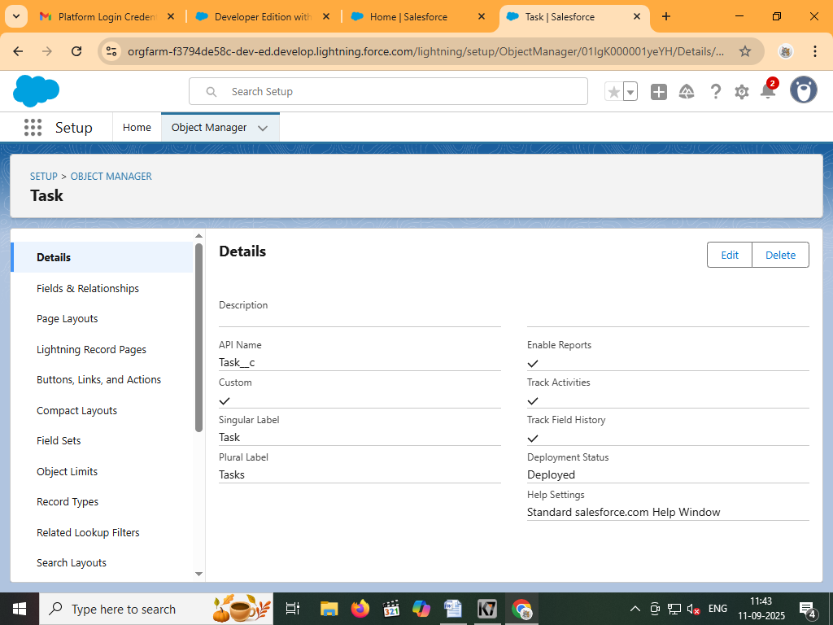

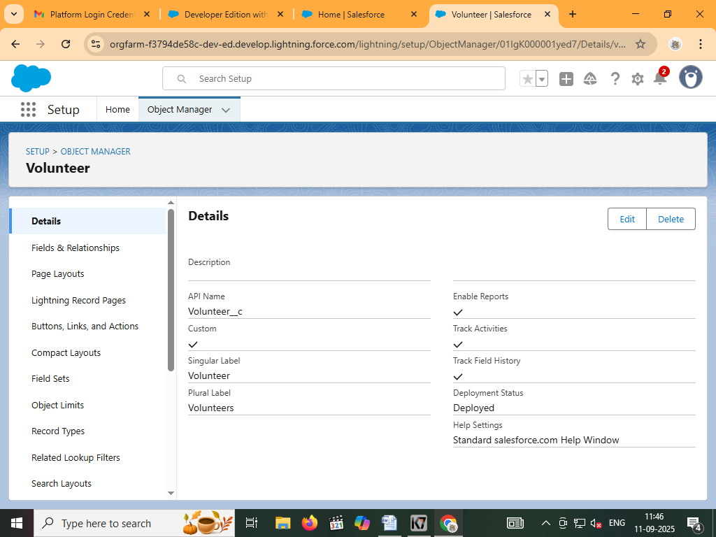

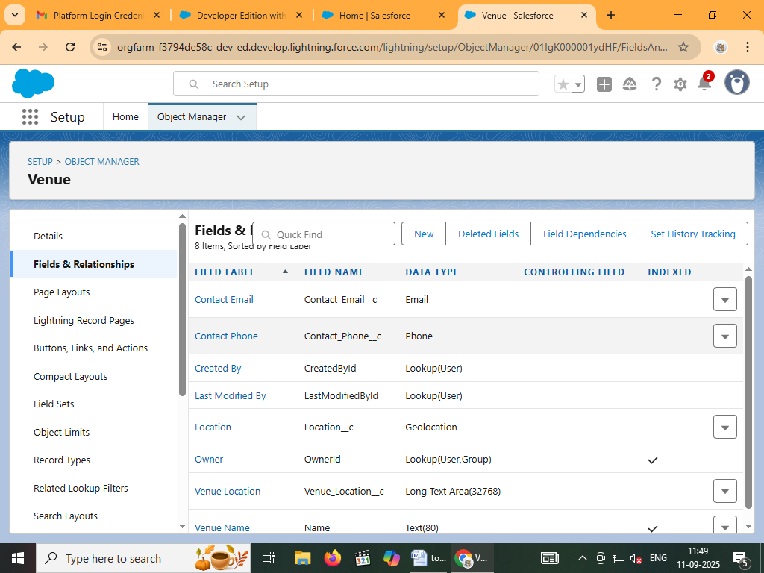

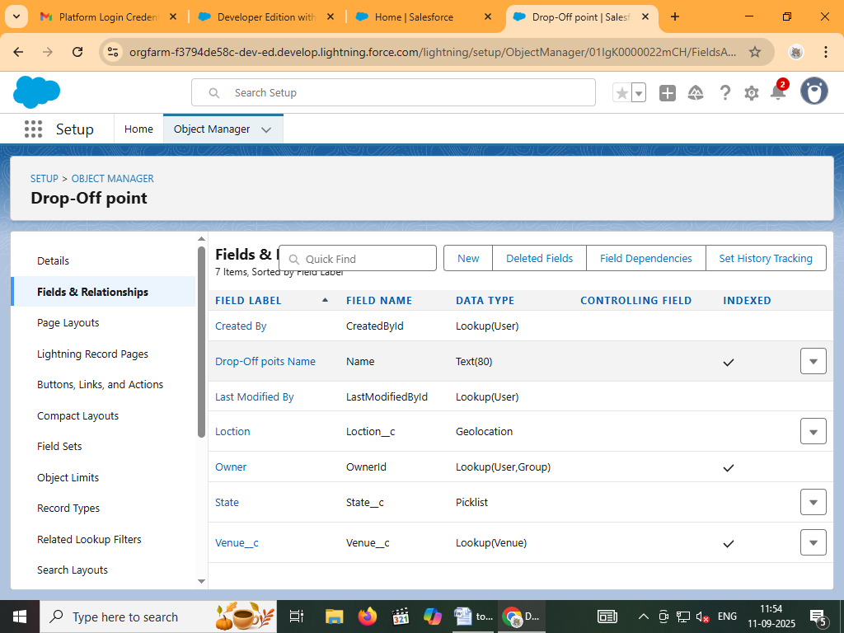

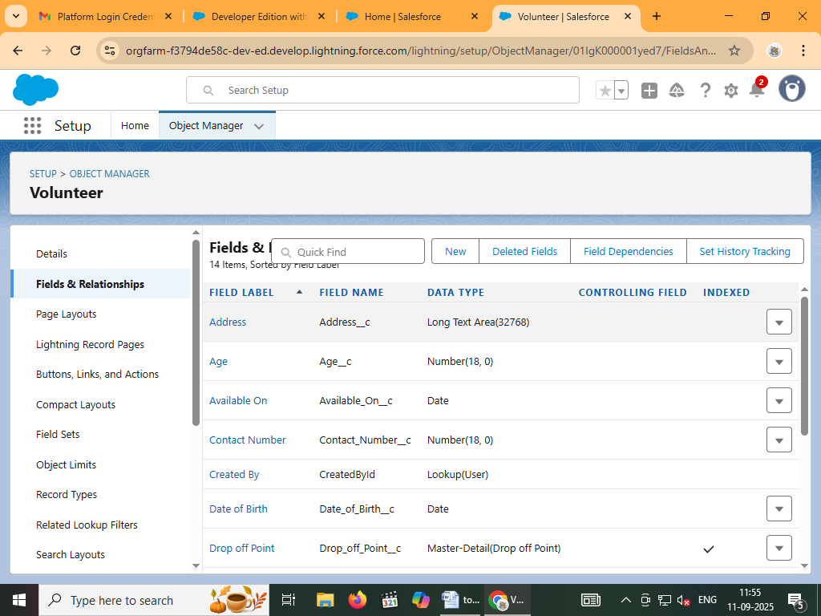

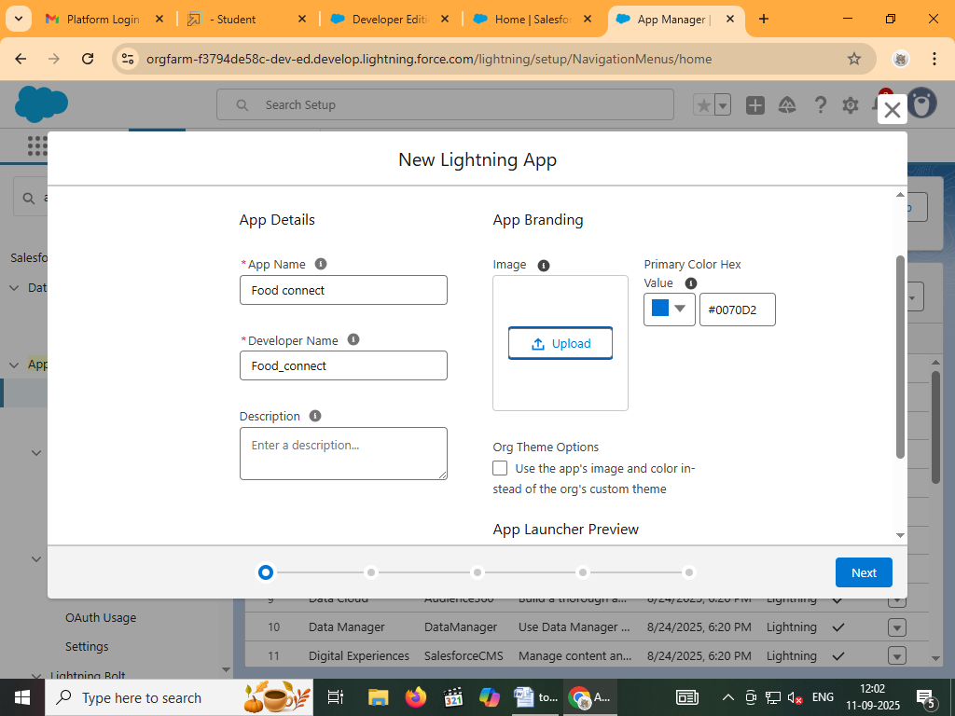

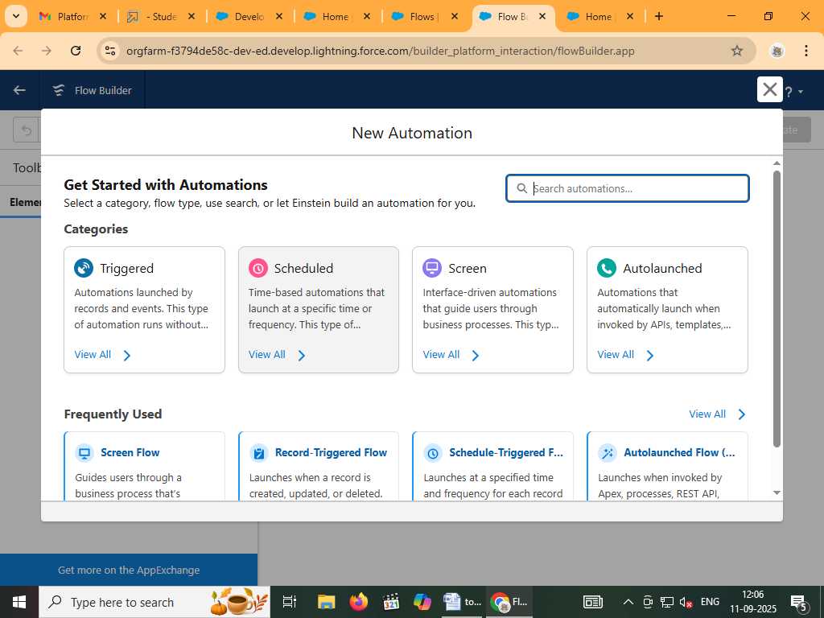

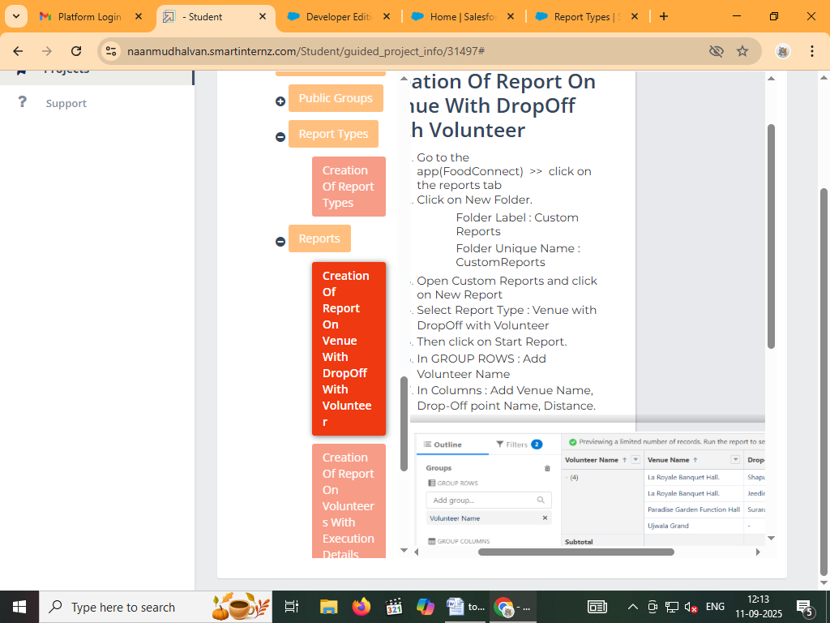

Advantages

**Reduces Food Waste:**

Donating surplus food prevents it from ending up in landfills, which minimizes the environmental impact of food waste, including greenhouse gas emissions.

**Provides Immediate Relief:**

It offers immediate nourishment to people experiencing hunger, providing them with food they might otherwise not have.

**Environmental Benefits:**

Diverting food from landfills conserves the resources (energy, water, land) used to produce the food in the first place.

Disadvantages

**Food Safety Risks:**

Leftovers may harbor bacteria that cause foodborne illness, and visual or olfactory cues aren't always reliable indicators of safety, posing a risk to recipients.

**Does Not Address Root Causes of Poverty:**

Surplus food donation offers temporary relief but does not tackle the systemic issues like income inequality and the cost of healthy food that lead to food poverty.

**"Rebound Effect" for Donors:**

If recipients of donated food save money, this can offset some of the climate benefits, as they may be able to spend their savings on other goods or services that also have an environmental impact.

Conclusion:

Supplying leftover food to the poor can significantly reduce food waste and combat hunger, but requires robust logistics, food safety protocols, and strong community partnerships to be effective. Key strategies include establishing food recovery programs with technology-driven logistics, collaborating with NGOs